**Ghulam Nabi Khan**

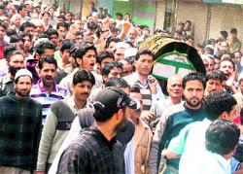

**About:** The Hindu that Federation's Sopore president Ghulam Nabi Khan was a prominent businessman in the north Kashmir town of Sopore. a chief of a beopar mandal who was also an activist of the ruling National Conference.

**Murdered on:** 24 May 2010

**Attack details:** Police sources told The Hindu that Federation's Sopore president Ghulam Nabi Khan was shot point blank while travelling in a horse-cart in the main chowk.

**Reason to him target:** The Hindu that Federation's Sopore president.

**Occupation:** Mr. Khan was a popular businessman in the town.

**Belief :** Mr. Khan was a popular trader and a sincere human being.

**URL :** <https://www.thehindu.com/news/national/other-states/Traders-leader-shot-dead-in-Sopore/article16302903.ece>

<https://www.tribuneindia.com/2010/20100524/j&k.htm>

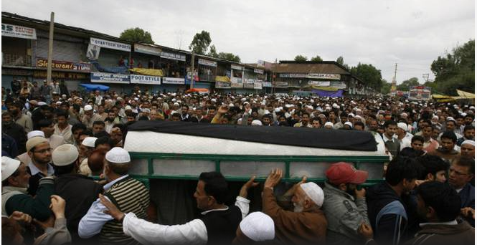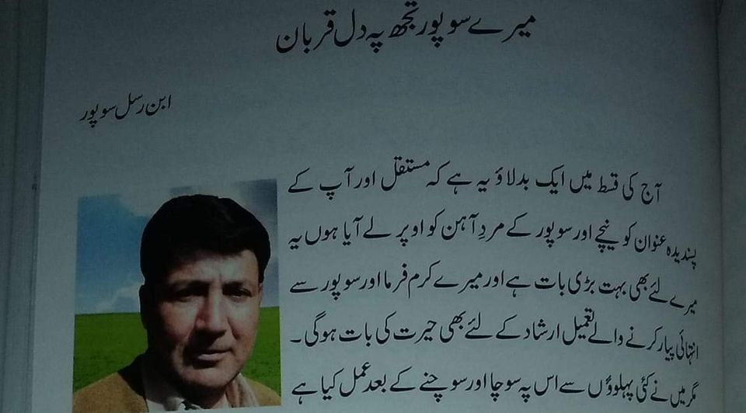https://th.thgim.com/static/img/1x1_spacer.png https://th.thgim.com/static/img/1x1_spacer.png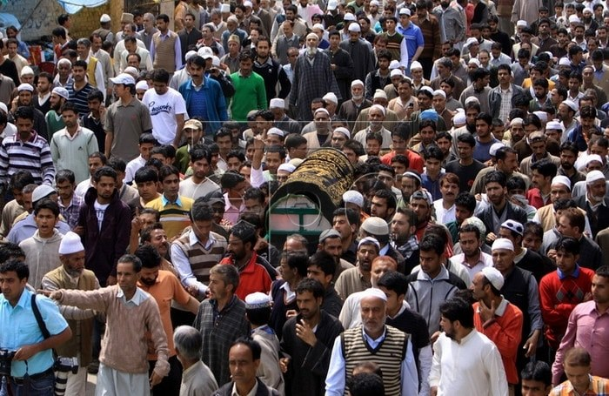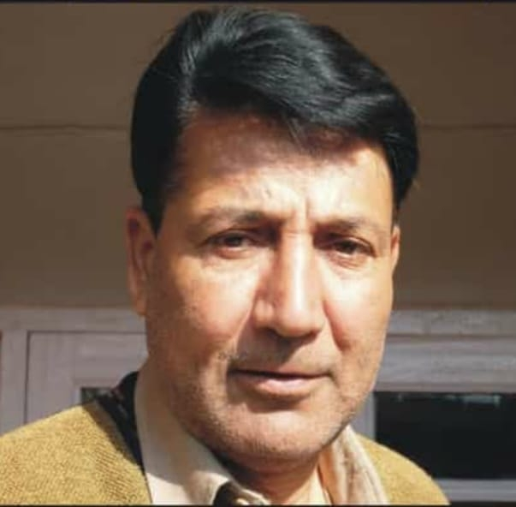

**https://th.thgim.com/static/img/1x1_spacer.png**